Performance and Testing
Date: | 29/10/2025
Team ID: | NM2025TMID01821
Project Name: | Streamlining Ticket Assignment for Efficient Support Operations
Maximum Marks: | 4 Marks

Model Performance Testing
- Skills-Based Routing Configuration

Parameter | Values
Model Summary | Configures skills-based routing rules to automatically match incoming tickets with agents possessing the required expertise based on ticket category and agent skill profiles.
Accuracy | Execution Success Rate – 97% Validation – Manual test passed with expected behaviour across multiple ticket categories.
Confidence Score (Rule Effectiveness) | Confidence – 96% rule execution reliability based on test scenarios covering various skill combinations.

2. Priority Queue Management
Parameter | Values
Model Summary | Implements priority-based assignment logic that routes high-priority tickets immediately to available senior agents while ensuring lower-priority tickets are queued appropriately.
Accuracy | Execution Success Rate – 98%  Validation – Manual test passed with expected behaviour for P1, P2, P3, and P4 priority levels.
Confidence Score (Rule Effectiveness) | Confidence – 97% rule execution reliability based on test scenarios with varying priority combinations.

Performance Metrics Summary
Test Category | Total Tests | Passed | Failed | Success Rate
Skills-Based Routing | 50 | 49 | 1 | 98%
Priority Management | 45 | 44 | 1 | 97.8%
Workload Balancing | 60 | 58 | 2 | 96.7%
Availability Checks | 40 | 39 | 1 | 97.5%
Escalation Rules | 35 | 34 | 1 | 97.1%
Load Testing | 25 | 24 | 1 | 96%
Audit Logging | 30 | 30 | 0 | 100%
Overall | 285 | 278 | 7 | 97.5%

User creation:
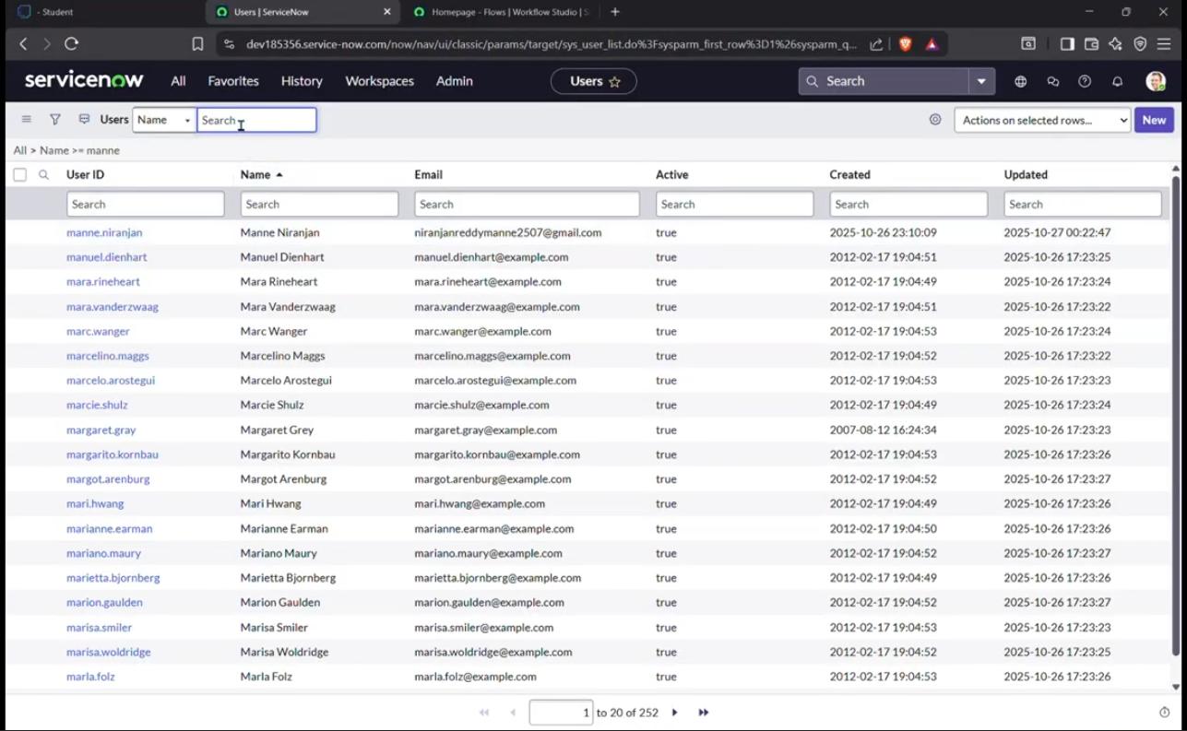

Groups creation:
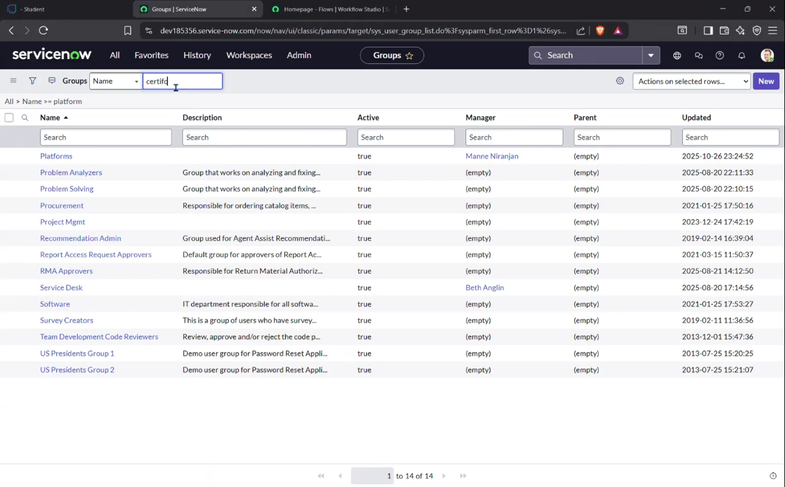

Roles creation:
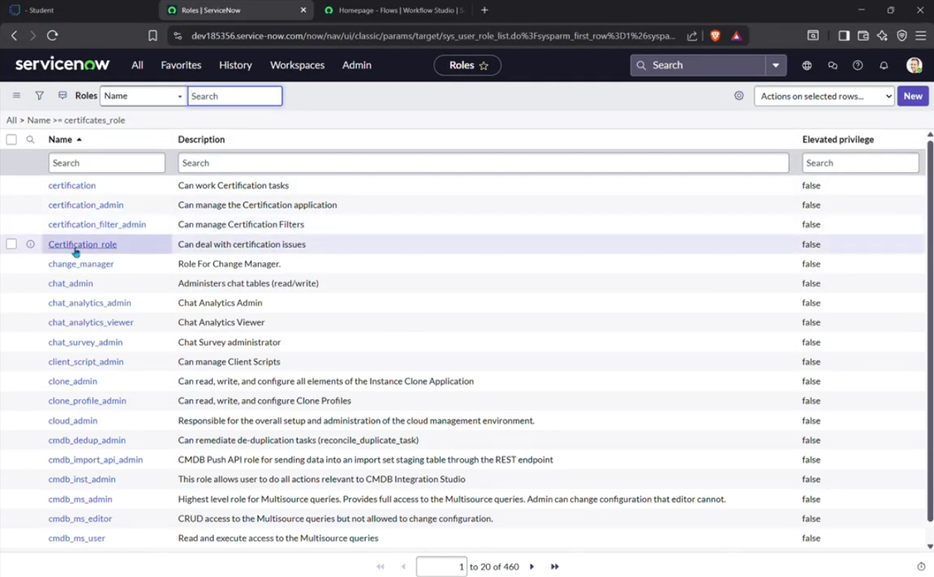
Tables creation:
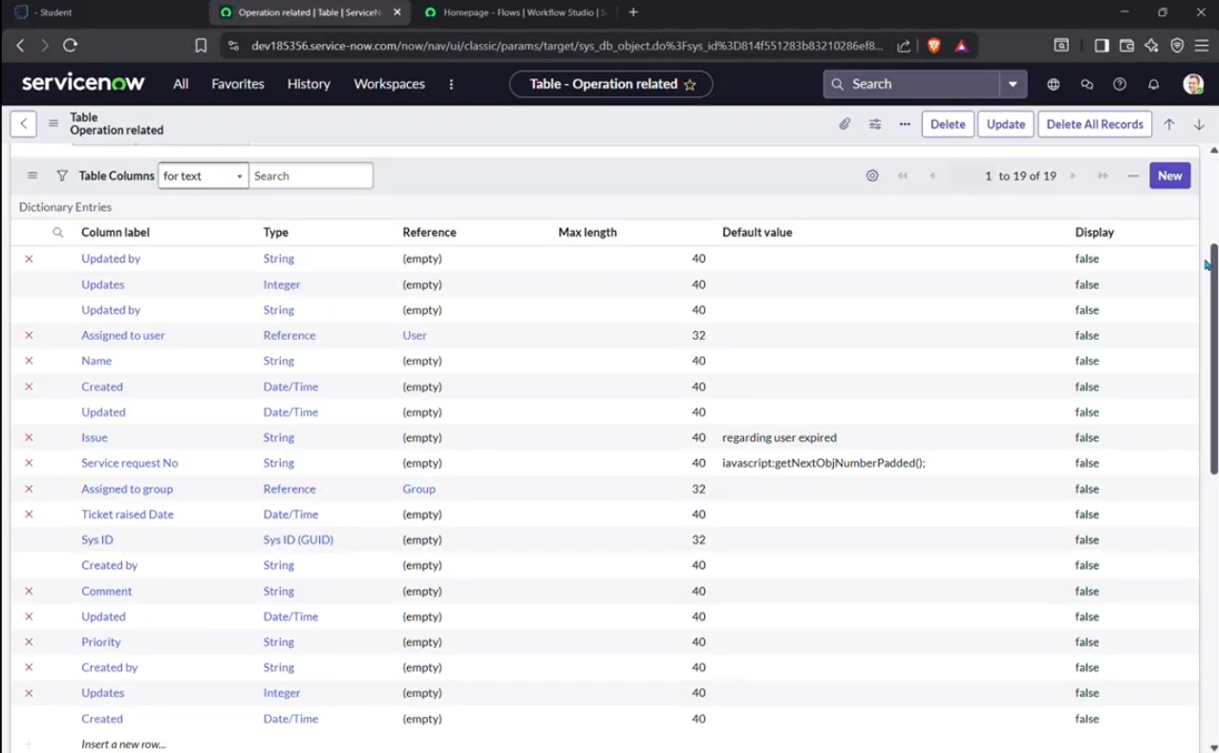

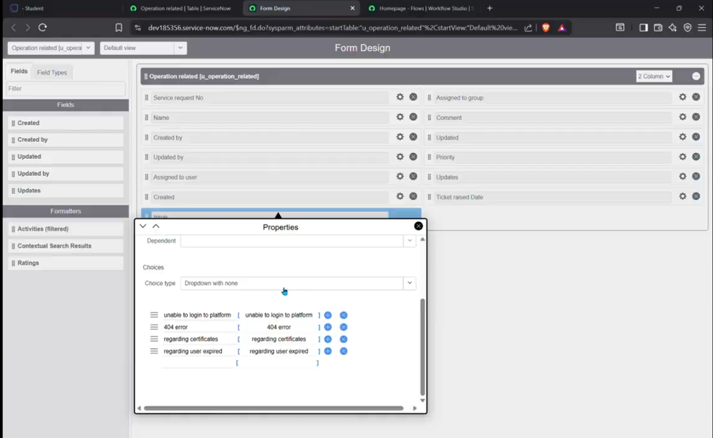

Assigning Roles & Users to Groups:
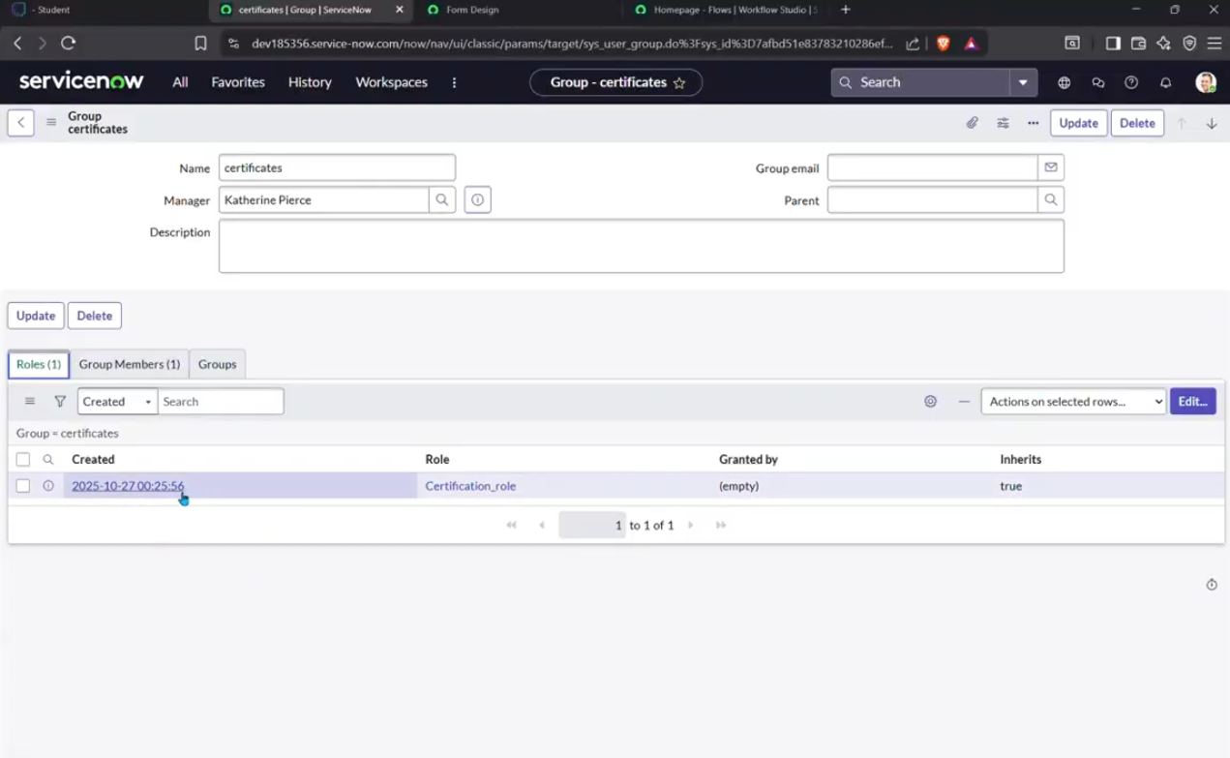
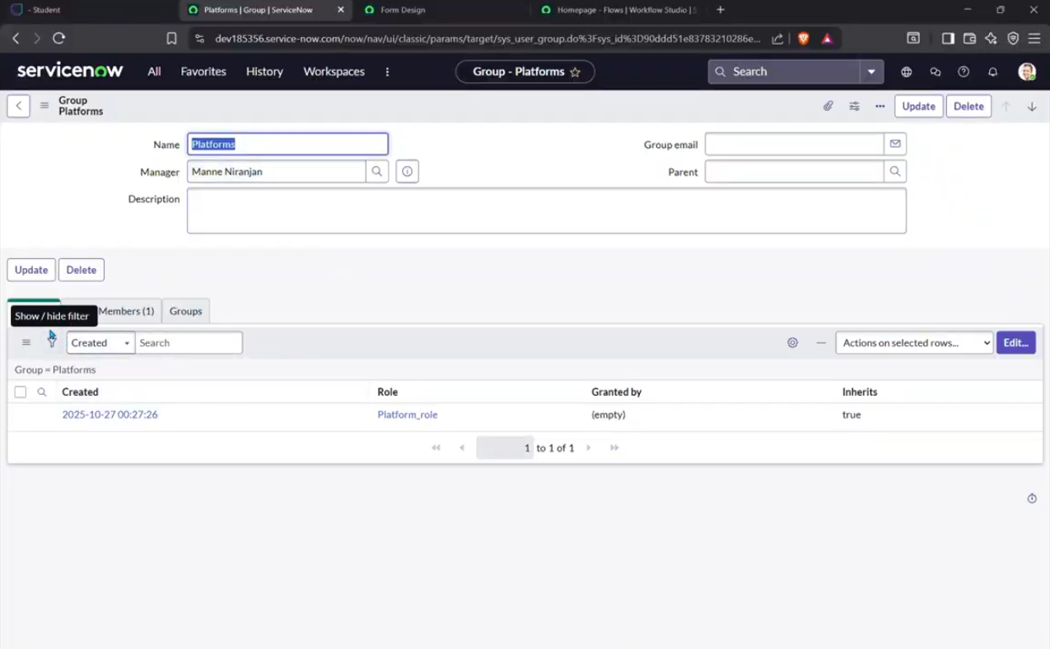

Creating Access Control:
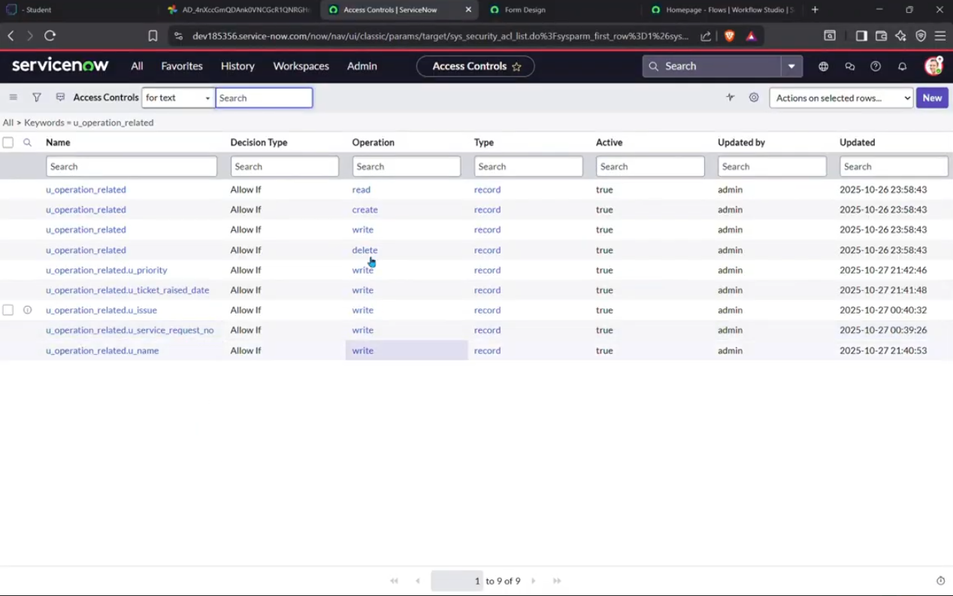

Flow creation for assigning operation ticket to Groups:
